Entity Framework Core 8.0 (OUTPUTS):

Lab 1: Understanding ORM with a Retail Inventory System:
OUTPUT:

Lab 2: Setting Up the Database Context for a Retail Store:
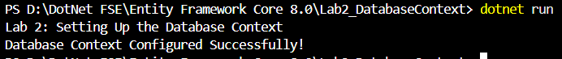
OUTPUT:

Lab 3: Using EF Core CLI to Create and Apply Migrations:

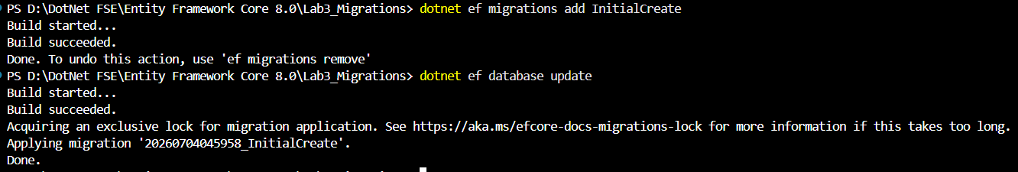
OUTPUT:

Lab 4: Inserting Initial Data into the Database :

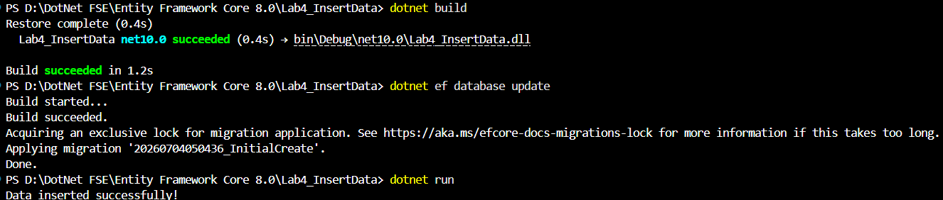
OUTPUT:

Lab 5: Retrieving Data from the Database:

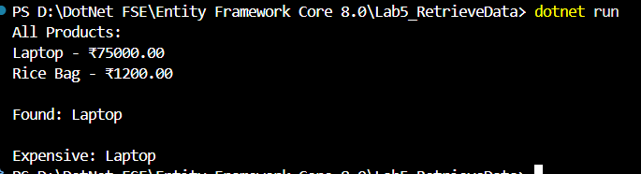
OUTPUT:

